1. **A3 Document**

**BACKGROUND:**

### The main purpose of conducting this lean lab game is to familiarize students with Lean philosophy and give them an experience with the Lean way of working

### Currently, the problem is, high throughput time of analyzing the blood samples in the lab. In this game, students will learn applying lean techniques to the current work flow, thus reducing the throughput time and increase the throughput rate of the overall work flow

**CURRENT CONDITION:**

* Four Techs are analyzing the Blood samples in the batch size of 3 using the push system in the laboratory
* All the workstations (Techs) are geographically dispersed
* The work flows from Tech 1 to Tech 2 to Tech 3 to Tech 4. And there is a travel time of 5s between each work station
* Tech 2 is expensive resource as she takes process time that is at least double of any other Tech

Process Map

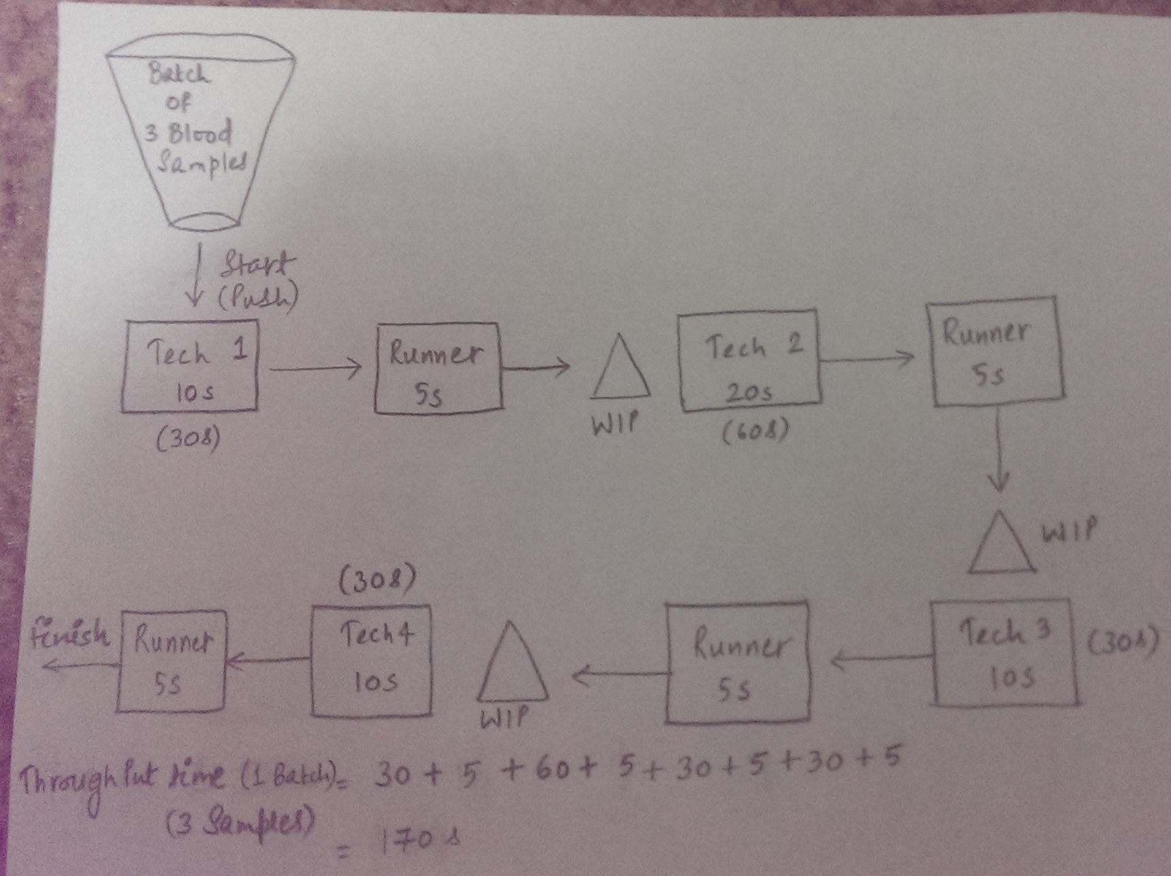

**GOAL:**

* Reduce the throughput time of the analysis of each batch and increase the throughput rate by applying Lean techniques in the lab

**ROOT CAUSE:**

Root Cause Analysis

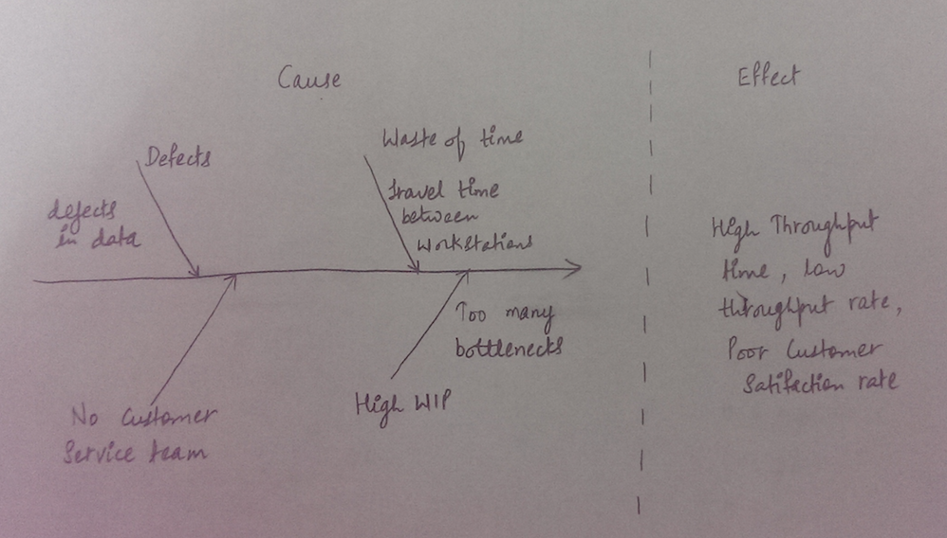

**COUNTER MEASURES:**

* Arrange the workstations in logical order so that there is less/no travel time
* Fix the defects in the data
* Reduce the batch size so that we can reduce WIP

**IMPLEMENTATION PLAN:**

* The working stations/workers are located in logic order with pull system in the work flow which reduced waste of time to get the samples from one station to other
* Defects are fixed in the data which reduced the bottlenecks
* Batch size reduced to 1 sample per batch resulting in low WIP of 70s

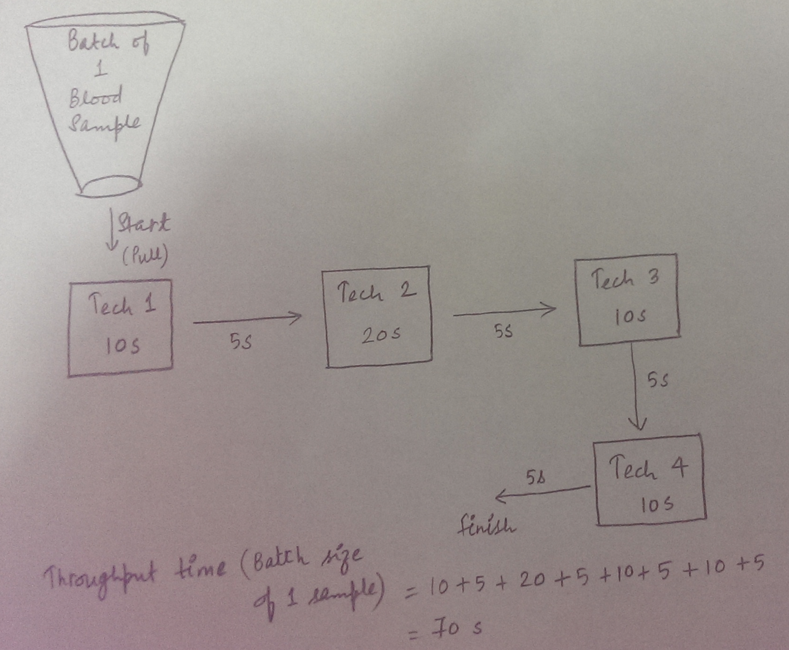

**FOLLOW-UP:**

* The implementation plan is working and the throughput time is reduced to 70 s.
* The lab can work on improving their low customer satisfaction rate by having a customer service representative/team to address the customer issues/questions.

a) iii

b) i

c) v

d) vi

e) i

f) iii

g) i

**2)** This is an immediate low-end encroachment (on 2*3 matrix) because lower price is driving this encroachment.

(I have referred the article “Will Disruptive Innovations Cure Health Care?

” By Clayton M. Christensen, Richard M.J. Bohmer and John Kenagy for this question)

Precisely, this is disruptive innovation, as it sneaks into the market from below. In this scenario, powerful players focus on sustaining innovations by creating new & advanced products targeting more-demanding customers where as the upstart companies introduce cheaper and simpler products meeting the needs of the less-demanding customers. The graph below illustrates this concept

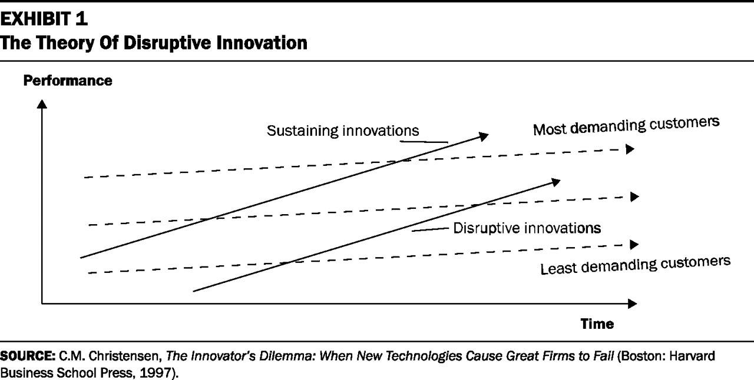

I do not agree with primary care physicians’ response (masquerading as advocates of patients’ rights) because the flawed logic behind such response is that the nurse practitioners and assistants can’t provide the same quality of treatment and may not be able to judge when the disorder is beyond their expertise. In fact, the studies have shown that with the appropriate training, the nurse practitioners and assistants can treat simple disorders with the same quality of treatment in that section of the market and can also be equipped with the knowledge of directing the patients to the specialists at the appropriate time.

I think their true reason for blocking nurse practitioners and assistants from treating simple disorders is to preserve their market dominance. This has forced highly trained physicians to treat simple disorders, which results in low income for them. Hence, to maintain their income, they treat more and more patients and thus spending less time with the patients, which reduces the quality of their treatment.

Instead of blocking nurse practitioners and assistants, physicians should take work towards enabling new system that’s characterized by lower costs, higher quality, and greater convenience. The healthcare industry can be divided into three tiers. In the simplest tier, diagnoses are based completely on rules. In Middle tier, diagnoses are based on pattern recognition and in the most complex tier, diagnoses occur in problem solving mode.

We can create a process in which the diseases in the simplest tier can be

handled by nurse practitioners and assistants and the more complex

pattern recognition and problem solving mode diseases can be

channelized towards specialists and highly trained physicians. Thus

instead of moving down market, these highly trained

physicians/specialists can move upmarket through these disruptive

technologies.

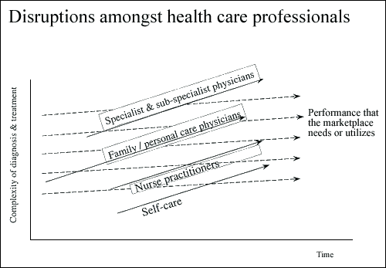

Source: <http://hbswk.hbs.edu/item/2270.html>

**3)** Reference - Internet. I browsed through many articles to understand this concept on the basis of which I have come up with following discussion.

The main question for start-up firms’ is, what if the customer doesn’t want the product they are building? Then it would be better for them if they find that out sooner than later. This could be achieved with smaller batch size. By working in small batches, a start-up can minimize the expenditure of time, money, and effort that could potentially be wasted.

Lean manufacturers such as Toyota discovered the benefits of small batches, which made their factories more efficient.

The goal of start-ups in building products is to be able to run experiments that will help them learn how to build a sustainable business. The Lean Start-ups respond to pull requests in the form of experiments that they need to run and formulate a hypothesis that they want to test. Their NPD team designs and runs the experiment, using the smallest batch size that will get the job done. Smaller batch size helps them to get through the Build-Measure-Learn feedback loop more quickly than their competitors and this ability to learn faster from customers is the essential competitive advantage that start-ups must possess.

Hence start-ups should release small

* Test small
* Integrate small
* Deploy small and deploy continuously

Changes in batch size affect two primary costs: the transaction cost and the holding cost. As batch sizes increases, inventory costs raise, which increases holding costs. But the transaction costs decrease, because it takes fewer transactions to cater to demand. The optimal batch size is the point where the total cost is lowest.

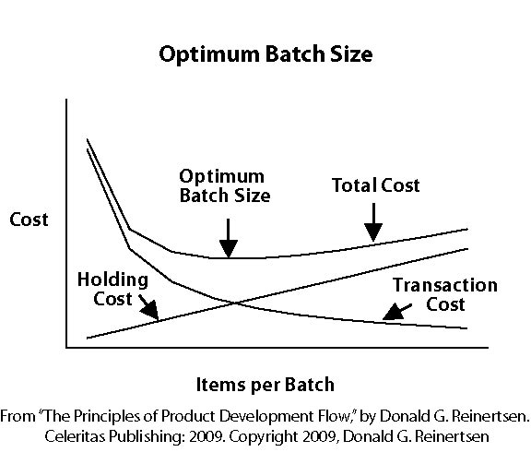

Companies that have utilized this methodology have shifted towards smaller batches and have benefitted significantly by improving their efficiency and decreasing the defects.

Following are few other advantages of small batch size, which lean start-ups exploit:

* **Small batches reduce WIP -** As seen inquestion 1 of this test, we could reduce the time of one cycle to 70 s from the initial time of 170 s by reducing the batch size of blood samples from 3 to 1. Similar concept is illustrated in the graph below where queue = WIP. Size of the shaded area is the size of the queue. It can be observed that queue size is proportional to batch size, which implies that we can reduce the cycle time without changing either demand or capacity

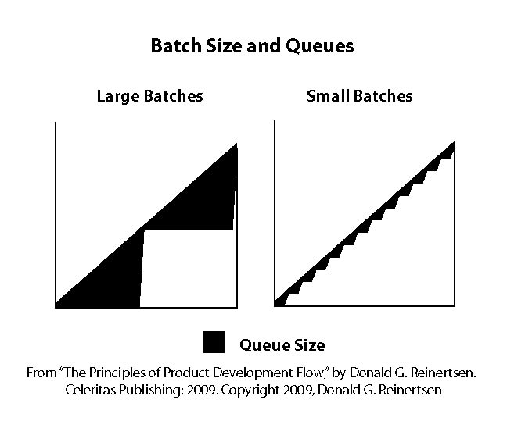

Queues delay feedback, causing workers to follow unproductive paths longer. They make it hard for companies to adjust to evolving market needs and to detect weaknesses in their product sooner.

* **Quality problems can be identified sooner with small batch size** -Thebenefits of finding and fixing problems faster outweighs the cost of stopping the production line
* **Small batches reduce variability in flow -** Reducing batch size reduces variability, and with lower variability they may find that current capacity is sufficient
* **Small batches accelerate feedback**
  + Fast feedback provides financial benefits because the consequences of failures increase exponentially when the feedback is delayed
  + A single incorrect assumption can force them to change hundreds of decisions
* **Small batches reduce risk -** Risk of failure is significantly reduced as testing happens continuously
* **Small batches reduce inventory cost-** Smaller batches increase flexibility and reduce inventory costs.

On the other hand, large batches reduce efficiency. They lower motivation and urgency of getting the work done. For example, an engineering team at an IT firm would be more motivated and determined to finish a module which is to be delivered in 5 days rather than the one which is scheduled to be delivered in 100 days. The lack of feedback might lead to demotivation. Large batches also cause exponential cost, as they tend to grow over time. Moving such batch forward results in additional work, rework, delays, and interruptions.

With large batches comes the need to maintain inventory. The inventories cost a lot. The inventory requires warehouse space and employees to maintain it. In addition, the inventory runs the risk of expiring, breaking or being stolen. Large batches also limit the company's ability to meet customer demand through flexibility.

**4)** Reference - Internet and Class Slides. I browsed through many articles to understand this concept on the basis of which I have come up with following discussion.

To climb the value chain, OEMs move from in house production to contract manufacturing (CM) to contract design manufacturing (CDM) to original design manufacturing (ODM).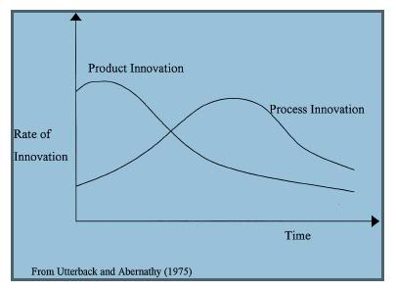

The graph above shows the impact of outsourcing on innovation.

Effective in-house manufacturing provides the best opportunity to harmonize product innovation with process innovation capabilities and also protect intellectual property. It offers additional barriers to the potential competitors.

Products that are manufactured in-house with innovative process technology can win the competition when their competitors cannot replicate their product’s attributes. Hence, in the graph above, we can see that the product innovation is highest initially (the phase of in-house production) and the process innovation is starting to improve.

Outsourcing enables OEMs to focus on their core competencies (marketing, R&D) while allowing EMS (Electronic Manufacturing Services) companies to provide manufacturing expertise. It helps in improving product design specifications with process capabilities and retains and protects intellectual property at the same time. The main benefits of outsourcing are:

* Reduction in costs and investments
* Additional Capacity
* Shorter time to market
* State of the art manufacturing capabilities
* Lower inventory costs

With the onset of EMS firms, OEMs started outsourcing manufacturing to CMs.

In this type of outsourcing, OEM firm controls the product innovation and outsources manufacturing and process innovation to CMs. Thus the CMs’ process innovation capability determines the cost reduction effectiveness, while the OEMs’ product innovation capability determines the value enhancing effectiveness. This means that outsourcing only manufacturing allows the two firms to specialize, focusing on their strengths. This can be seen practice when firms such as Apple focus on product design, while their supplier (e.g. Foxconn) focuses on manufacturing and process innovation. Hence, in the graph above, we can see that the product innovation is high when OEMs outsource to CMs and the process innovation also improves significantly due to the CMs manufacturing capabilities.

OEMs benefit from CMs in many aspects:

* Cost reductions that a CM passes on to OEMs as CMs serve multiple OEM customers. This enables CM to reduce the cost of doing the business and increase their capacity utilization rates
* Since CMs operate in less expensive geographical regions like China, India, the labor costs are less in these regions which also help OEMs in cost reduction
* OEMs benefit from faster time-to-market by working with CMs, leveraging their deep knowledge gained through managing the multiple processes tied to these solutions.

As the CMs built up their technical know-how, OEMs started to outsource product design and development related activities to CMs. This trend created a new outsourcing model; contract design manufacturing (CDM), in which an OEM gives concept designs to a CDM firm and then both collaborate on physical design and development (product and process innovation). This trend helps OEMs to improve their product design and development. This led to the transition from CM to CDM. In the CDM model, OEMs own the intellectual property of designs and have complete control over the characteristics of a new product.

In this setting, OEMs submits the initial design prints to the CDMs. The CDM assesses the requirements against their asset base and suggests modifications in the design to the OEMs because of the assets constraints they possess, to which OEMs usually agree upon. This kind of manufacturing method declines the product innovation where as stabilizing the process innovation.

As EMS firms tested the CDM model, they started to outsource original design and manufacturing to EMS firms, thus giving rise to ODMs. OEMs find ODMs more attractive as they offer advanced designs and the ability to bring a new product to the market quickly, thus giving OEMs the competitive advantage and large cost savings. Studies show that, 70% of a product’s manufacturing cost is determined by the end of the design process. Only 35% of the cost reduction opportunities are left after that stage. Hence, integration of design and manufacturing processes is crucial for making cost reductions and ODMs provide that because of which the OEMs transitioned from CDM to ODMs.

In the ODM setting, both the process and the product innovation decisions are controlled by them and OEMs have no decisions to make after deciding to outsource. Since there are few dominating ODMs in the market, it is inevitable that most of OEMs have a common ODM, which leads to duplicity of products in the market with different brands. This leads to decline in product and process innovation as shown in the graph above.

Lastly, the graph above shows that if the firms are specialized such that the CMs dominate in process innovation and the OEMs in product innovation, the investment in innovation might be higher (where each firm controls one innovation decision) than that when outsourcing both manufacturing and design (CDM/ODM).

**5)** Reference - Internet. I browsed through many articles explaining, what drives automotive industry towards success to understand this concept on the basis of which I have come up with following discussion.

Tesla’s strategy is to enter the market at the high end and then gradually move down below. It has already entered the market at high end with Roadster and Model S, which have been hugely successful.

Tesla’s growth has been due to:

* Superior quality design and user experience because of extensive expertise in design, development and manufacturing leading to. Their competitive edge is mainly because of the in-house concept development/product design/manufacturing/sale of its vehicles.
* Building strong relationships with their customers through in-store experience and online communities. The stores educate customers on their services and online communities are for the customers to discuss their vehicles, raise issues, provide ideas etc. Tesla is known for its best customer experience like Apple and the value it provides to its customers like superior quality, environment friendly and safety.
* The positive customer experience that encourages Tesla to offer only built-to-order vehicles, which minimizes waste and increases profits.
* Their continuous commitment to ease of support. For example, when the Model S caught fires due to the damage to the battery at the base of the car, Tesla announced to equip old vehicles with shield free of charge and new vehicles with triple shield.

All these growth factors have helped Tesla to break into the list of top 5 car brands based on a survey conducted by Consumer Reports while being just 10 years old in this industry.

The virtuous cycle which has contributed to Tesla’s growth is as shown below. It begins with investment in R&D, which leads to better quality vehicles, and EVs. High quality vehicles provide positive customer experience leading to increased sales. The revenue derived from increased sales is reinvested into R&D, which allows Tesla to explore new opportunities and make high profit.

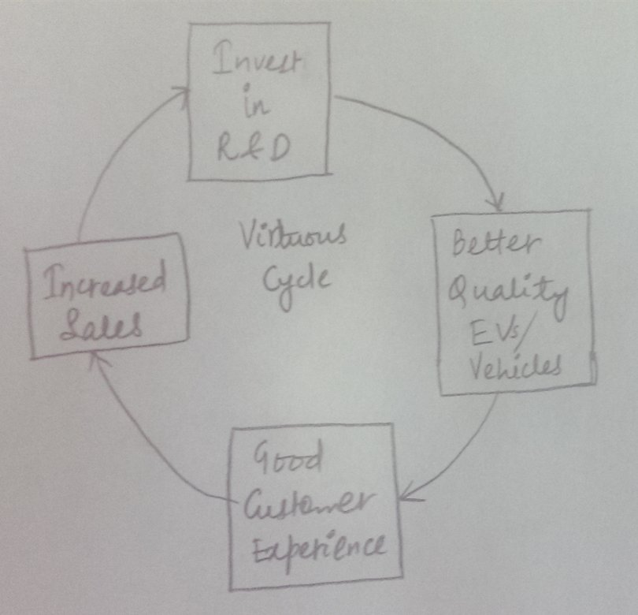

I’m very positive about the above virtuous cycle materializing in future looking at Tesla’s business model so far. I feel that following factors will contribute to its success:

* If Tesla is able to improve the efficiency of its operations while continuing to deliver on its value proposition to customers, its future looks very promising to me.
* It’s recent move to grant access to its competitors to their technology will help Tesla to accelerate the growth of EV industry as that will lead to more number of charging stations, leading to increased sales of EVs which will in turn lower the manufacturing costs. Lower manufacturing costs will increase sales and thus encouraging R&D.
* In Feb 2014, they announced the development of $5 billion battery “gigafactory” which may help them to convert their dream of mass-market electric vehicle a reality.

The only risk, which might hinder its success, is the delay in launching its products for which Tesla has a reputation. This might give an edge to their competitors who can exploit this opportunity and release similar products at lower price in the market before Tesla does and hence encroaching on Tesla’s market share.

**6)** Process innovation is about improvements in how goods/services are designed, produced, distributed and serviced like Groupon. Product innovation is about coming up with new products like iPad.

As seen in the two examples mentioned in the question: Pfizer’s Viagra and Apple’s touchscreen phones, it wasn’t very difficult for their competitors to imitate their product designs and encroach on their market with lower prices.

Even in the case of ODMs, we observed that product innovation is declining as most of the OEMs share one ODM and hence end up with similar products, leading to less profits. Replicating products is much easier than replicating process.

On the contrary, process innovation is more sustainable than product innovation because:

* The process innovation of any firm is not directly visible to its competitors and hence it takes time for its competitors to imitate them on that front. This is what sustained Zara in the fashion market for long, as its competitors could not figure out its business innovation model for a long time.
* It is quite challenging for the competitors to copy and adapt to a process innovation technique.

As a result, many companies pursue business model innovation as a defensive move to protect a dying business or defend against aggressive competitors.